**Tools and Contact Details:**

* **Illustrations: Mr.Bharat Rai (Illustrator), email:** [**phoenixesare@gmail.com**](mailto:phoenixesare@gmail.com)

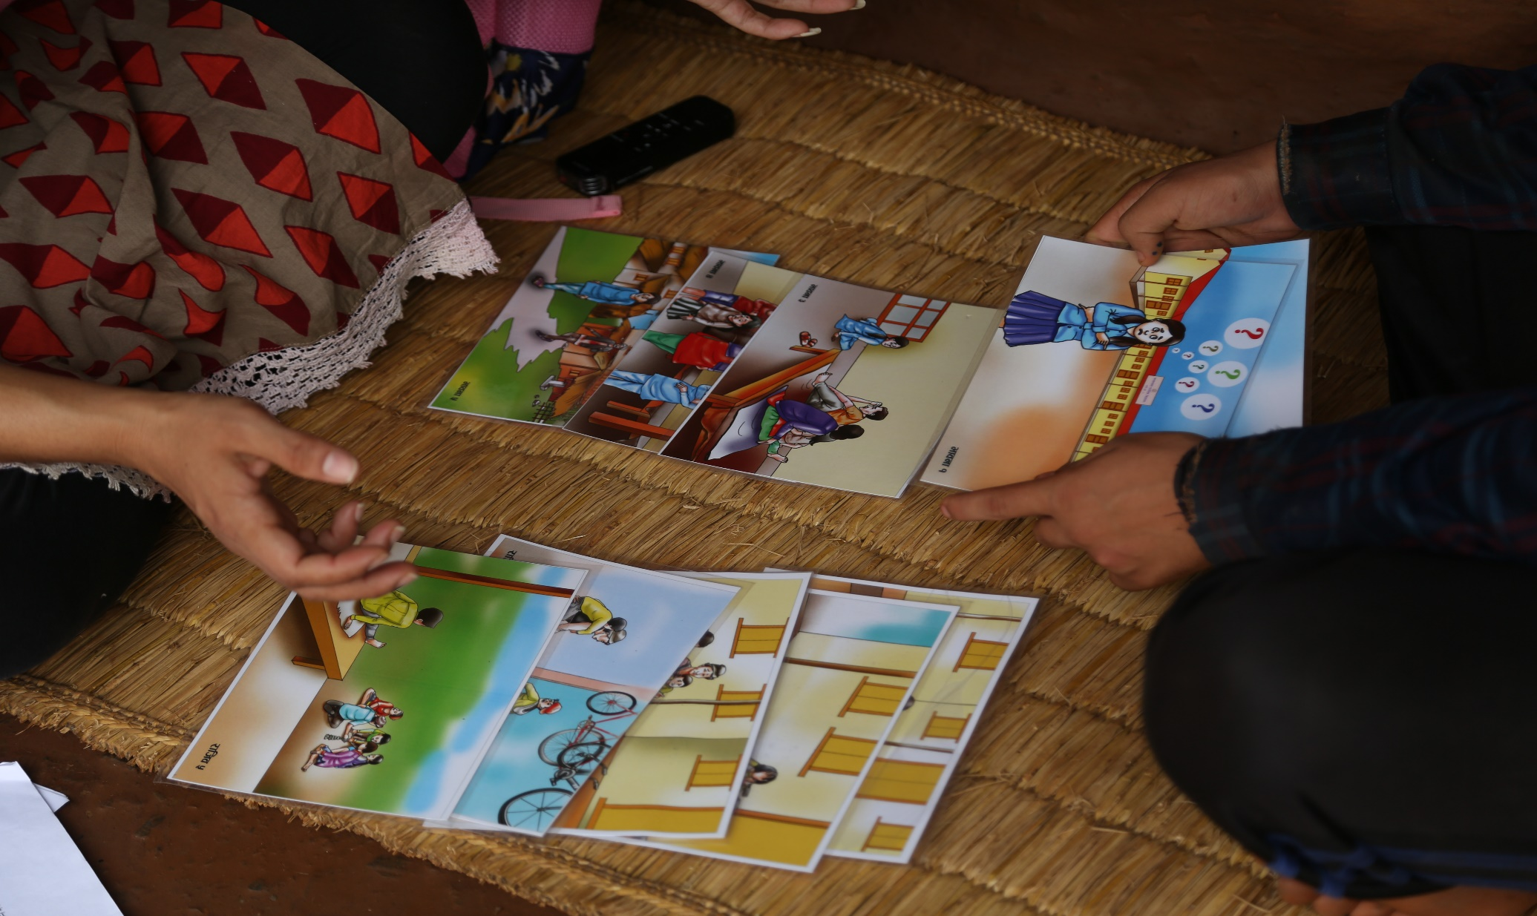

* **Dolls: BODHI CRAFTS, Kupondole Lalitpur, Nepal. Phone:9849806206**

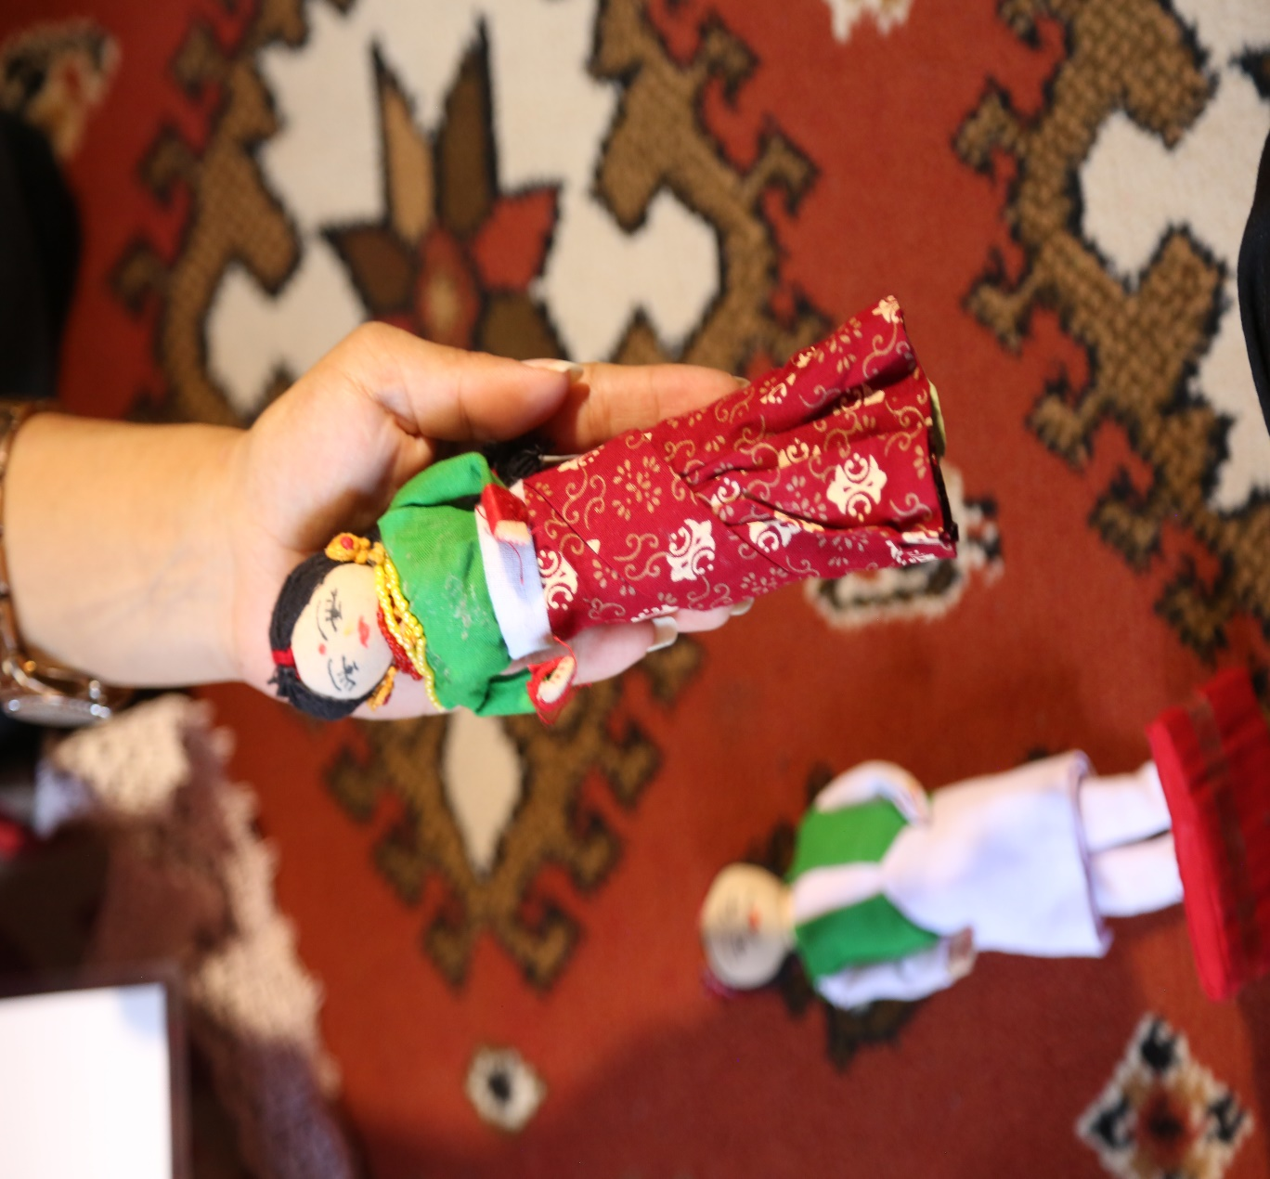

* **Dice: BODHI CRAFTS, Kupondole Lalitpur, Nepal. Phone:9849806206**

